New Products of HR-150AⅠ Rockwell Hardness Tester

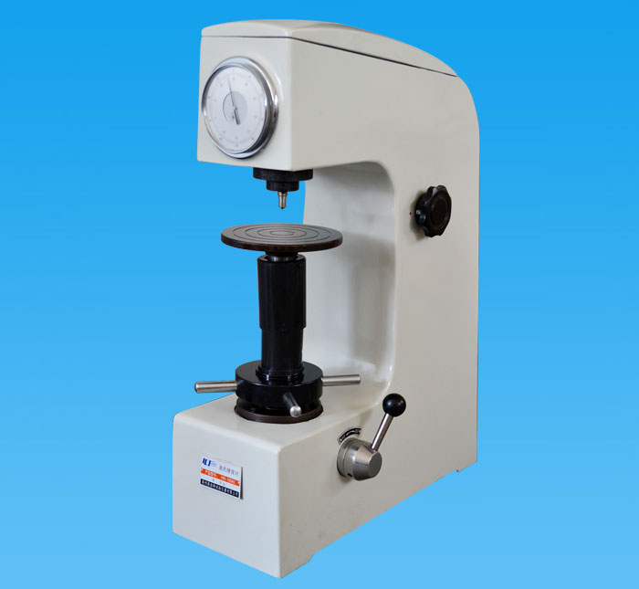
The HR-150AⅠ Rockwell hardness tester is improved on the basis of the HR-150A Rockwell hardness tester. It is the most popular Rockwell hardness tester with four outstanding advantages:
1. Its structure is more concise and reasonable.
This machine fully retains the essence and advantages of the HR-150A Rockwell hardness tester, and at the same time makes reasonable improvements to the complicated parts. The buffer mechanism is operated by a handle to complete the application and removal of test force. It avoids the phenomenon that the HR-150A loading handle cannot be opened and the unloading handle cannot be reset. The structure is simple, easy to operate, and greatly improves work efficiency.
2. The test force is more stable, and the display accuracy is greatly improved.
Compared with the HR-150A, the weight system of this machine adopts the patented universal connection boom, instead of the plum blossom top rod and the lifting ring, which completely changes the test force caused by the swing of the weight due to various reasons and the value is unstable. The accuracy is not accurate.
3. The installation is easier.
This machine reduces the requirements for the levelness of the installation test bench. As long as the test bench is stable, the basic level can meet the installation requirements of the machine to make it work normally.
4. Transportation and handling are more casual.
The weight system of this machine has an automatic reset function. However, HR-150A may easily cause weights to shift during transportation and cannot work normally and cannot automatically recover. It is not easy to repair by non-professional maintenance personnel. The machine can automatically align and reset due to the universal connection boom. No manual repair is required, and it can be transported and placed at will, which greatly reduces the failure rate.
In summary, the HR-150AⅠ Rockwell hardness tester has many advantages such as simple and reasonable structure, stable and accurate accuracy, easy installation and use, low failure rate, and convenient maintenance. It is the first choice for the majority of users to conduct Rockwell hardness test.

